Mineral Density Lab

Every mineral on Earth has a different density. The density of the minerals help determine the composition of each of Earth’s layers. For this lab, find the density of these minerals or rocks and then determine, from their density in which layer they are most commonly found.

# Group Roles

Recorder:

Mass:

Volume:

Calculator:

# Part A

Calculate the density of each sample

|  |  |  |  |
| --- | --- | --- | --- |
| Substance | Mass (g) | Volume (mL) | Density  D=m/V |
| Iron |  |  |  |
| Nickel |  |  |  |
| Basalt |  |  |  |
| Olivine |  |  |  |
| Granite |  |  |  |
| Silica (Honors) |  |  |  |

# Part B

Based on the data you calculated in Part A, place the samples into the table below based on their density, from least dense (floats) to most dense (sinks).

|  |  |  |
| --- | --- | --- |
| Layer | Density (g/ml) | Substance |
| (Least Dense) Continental Crust |  |  |
| Oceanic Crust |  |  |
| Mantle |  |  |
| Liquid Outer Core |  |  |
| (Most Dense) Solid Inner Core |  |  |

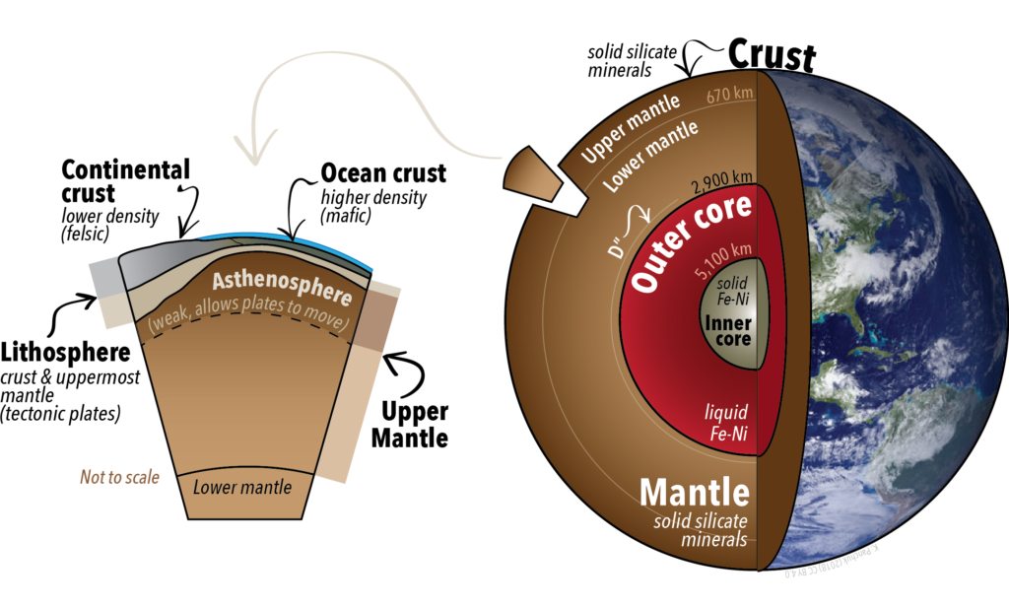

1. Do the densities you calculated and the materials you listed in the Part B table match what scientists believe exist in each layer?
2. If not, what might have happened or why might the lab not match reality?
3. (Honors) Where would Quartz fall in the layers of the Earth?

Why?